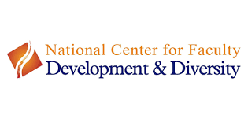

NCFDD Resource Guide

Updated July 2020
Table of Contents
NCFDD Resource Guide 1
Updated July 2020 1
National Center for Faculty Diversity and Development (NCFDD) 3
What’s Included? 3
Semester-Long Curricula and Programs: 3
Resources and Appendices 5

National Center for Faculty Diversity and Development (NCFDD) - Founded in 2010, the National Center for Faculty Development & Diversity is an independent professional development, training, and mentoring community for faculty members, postdocs, and graduate students. NCFDD is100% dedicated to supporting academics in making successful transitions throughout their careers.

To date, NCFDD has:

- Partnered with 230+ colleges and universities as institutional members
- Mentored 6,000+ faculty members in Faculty Success and Post-Tenure Pathfinders Programs where empirically-grounded methods improve productivity with the support of intense accountability, coaching, and peer support,
- Facilitated more than 350 workshops both on-campus and virtually
- Hosted 50,000+ academic writers in 14-Day Challenges
- Supported over 175,000 academics online through Core Curriculum and monthly guest-expert webinars and multi-week courses

What’s Included?

- Live and recorded webinars
- Community writing groups and writing challenges
- Interactive forums
- Library of career development and writing resources
- Weekly Monday Motivator
- Resources for staying on track and productive during Covid-19
- Optional email subscription

Semester-Long Curricula and Programs:

Faculty Success Program (FSP)

- Faculty Success Program helps faculty members:
  - Set achievable personal and professional goals that align with institution’s priorities and your own values.
  - Create a realistic and concrete plan to meet goals.
  - Establish and maintain a healthy and sustainable daily writing habit.
  - Develop a publication portfolio that will help meet institution's criteria for promotion.
  - Better manage time spent on teaching, service, research, and writing so that it aligns with goals.
  - Identify obstacles and learn strategies to move through them.
  - Prioritize physical and emotional health.

How Does FSP Work?

Each FSP participant is assigned to a small group (3-4 people) that is led by an NCFDD-
Certified Productivity Coach. Every week at a recurring time, participants meet for their small-group coaching call with their coach. During this call, participants will share their goals for the week as well as review the previous week’s goals.

Participants will complete the self-directed weekly modules as well as coach-guided homework every week, estimated to take roughly 1.5 to 2 hours. Every week-day during the program, participants will log on to the FSP platform, WriteNow, to check in and track their daily progress on writing, research, and personal goals.

﻿By the end of the program, participants will have developed the skills and habits they need to move forward with increased research and writing productivity and a better work-life balance.
*See Appendices A -C

Post-Tenure Pathfinders

“Winning tenure and promotion is a major transition for faculty members. As thrilling as it is to reach a goal you’ve worked hard to achieve, once the dust settles, many faculty members feel confused, unsure how to adjust, and/or overwhelmed by newly escalated expectations for service.

While the tenure transition is critical, most campuses don’t provide a structure or space for faculty to reflect on the next chapter of their career and make intentional and informed decisions about the most important question - what’s next? Without space for reflection, transition, and future-planning, many faculty don’t make a conscious transition and end up over-worked, exhausted, and burned out in a short period of time.”

NCFDD has designed the Post-Tenure Pathfinders program to provide a space and community for tenured faculty to pause, engage in a discovery process about next chapters, and build the support network necessary to move powerfully new directions. Small group sizes and 1-on-1
Coaching promotes accountability.

Goals of 12-week program include:

- Reconnecting with professional passions
- Exploring potential post-tenure possibilities
- Making the identity transition from "junior" to "senior" faculty
- Deciding how to effectively use new power on campus
- Releasing mindsets that were only effective pre-tenure
- Picking a post-tenure pathway
- Constructing a new mentoring network

Resources and Appendices

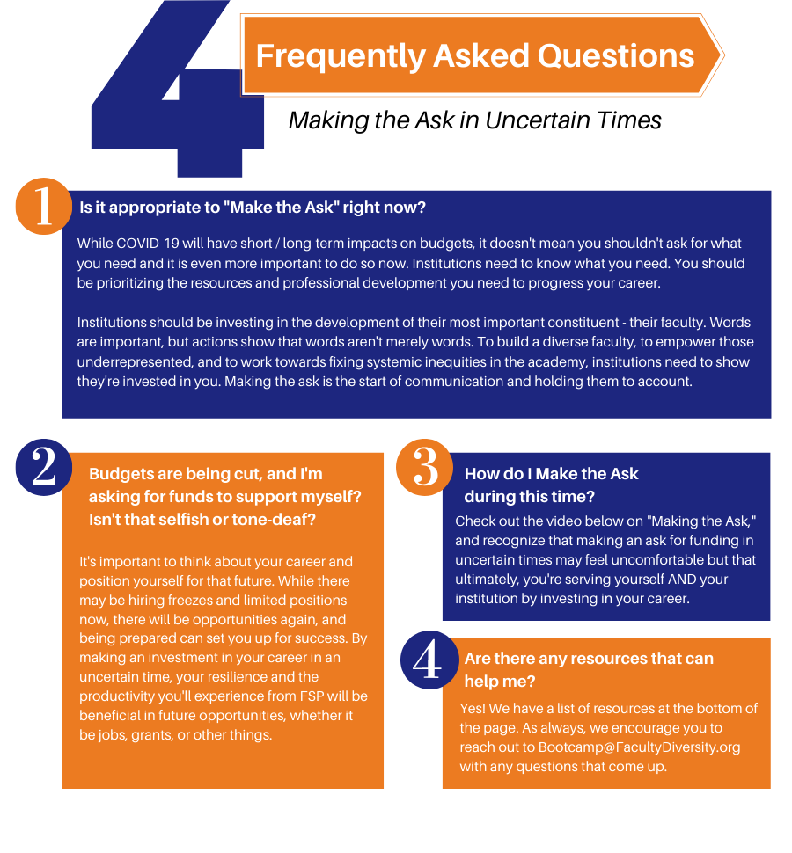
Appendix A

Appendix B
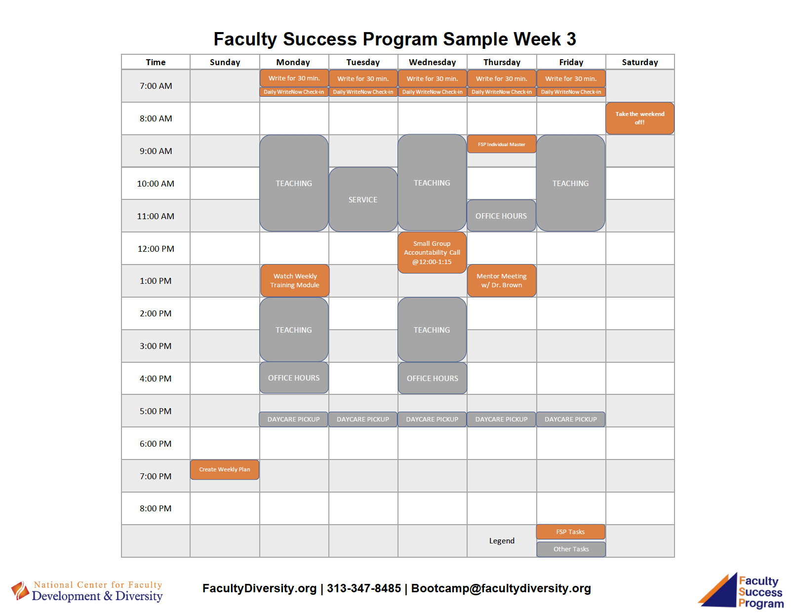
`

Appendix C

TEMPLATE FOR FACULTY REQUESTING INSTITUTIONAL SUPPORT FOR PARTICIPATION IN THE FACULTY SUCCESS PROGRAM

Successful requests for institutional support/sponsorship for the Faculty Success Program tend to have three things in common: 1) the writer demonstrates that they have already participated in an NCFDD program and found it useful because it offers something different than what's currently available on their campus, 2) there is a clear explanation of how the program fits with existing institutional priorities and mission, and 3) there's an explicit willingness to share what the participant has learned afterward. Here's a funding request template to give you a sense of what that might look like:
[insert opening pleasantry]
I recently participated in a workshop offered by the National Center for Faculty Development and Diversity. I found the workshop to be extraordinarily helpful as a professional development training opportunity because it [insert a concrete benefit that is not currently offered at your institution]. I think I would benefit greatly from participating in the NCFDD Faculty Success Program. It is a 12-week intensive mentoring program designed to increase writing productivity and retention, as well as build community among under- represented faculty. I would like to utilize this program to [insert goal that is consistent with -- and in the language of -- your institution's priorities/mission/goals]. I think participating in this intensive mentoring program would increase my [insert valued outcome] and propel my career forward more effectively than figuring these things out on my own. You can review additional information about the program by visiting the Center's website: Faculty Success Program.
Tuition for the program is [insert tuition]. I am wondering if [the department/your office/etc...] would be willing to support my participation in the program as part of our commitment to [insert appropriate value that is explicitly stated in the institution's mission]. I am hoping that after participating in the program, I will be able to create a similar community of support on our campus.
Thanks for your consideration and I look forward to hearing from you.

