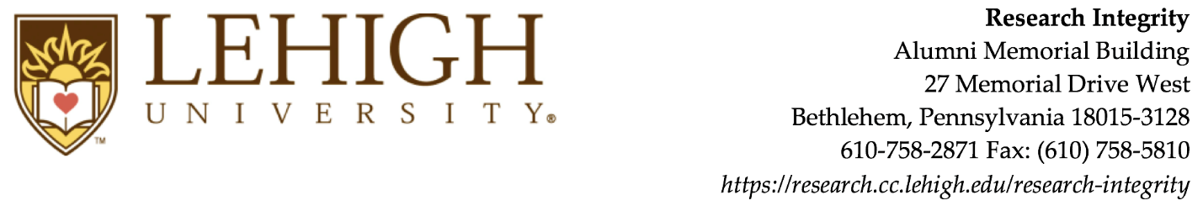
Request for Waiver of IRB Review for Class Projects
Instructor Name and Title
Department |  |  | Campus Address
Email |  |  | Office Phone
Course Number |  |  | Course title
Semester |  |  | Year

** Please attach a list of the projects, including each project title and the names of the students working on each project **
Describe the class assignment (or attach syllabus or class handouts highlighting relevant parts).

Describe the procedures for:
Maintaining confidentiality

Minimizing risk

Monitoring the research.

Waiver Requirement Checklist
No publication and/or presentation of the results of the project activities outside Lehigh University.
Project activities are no more than minimal risk to participants. “Minimal risk” is defined as the probability and magnitude of harm or discomfort in the research are not greater in and of themselves than those ordinarily encountered in daily life or during the performance of routine physical or psychological examinations or tests.
No participants under the age of 18 or members of vulnerable populations (e.g. prisoners, persons lacking capacity to give informed consent).
No project involving deception of participants
No projects in which participants could reasonably feel physically or psychologically threatened by the investigator (e.g. use of weapons, verbal threats, striking an intimidating pose)
No projects involving collection of information about the participants’ own: sexual history; medical history; mental health history; religious orientation and views; substance use and abuse; war experiences; criminal history; racial, ethnic biases/views.
---------------------------------------------------------------------------------------------------------------------------------------------------
Faculty Instructor Assurance
I accept primary responsibility for safeguarding the rights and well-being of the human subjects and to:
- Train students in the proper conduct of research and the protection of human subjects. (It is HIGHLY recommended that all students complete the NIH or CITI human subjects training)
- Review Student Class Project Applications, determine if each project qualifies for a waiver, and require standard IRB review if not;
- Ensure that students get informed consent from participants ;
- Review all methods and instruments used in each project;
- Monitor the research and inform the IRB immediately of any significant problems that arise.

Faculty: _____________________________________________________ ______
Signature Date

