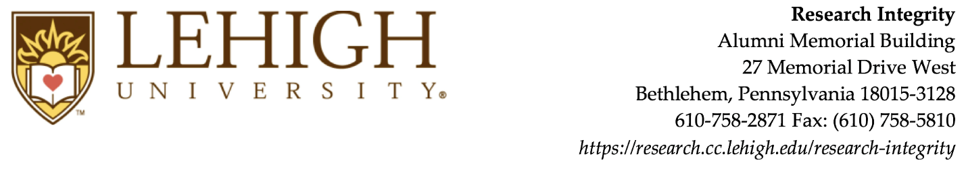

Lehigh University Institutional Review Board
International Research Appendix
Research with human subjects conducted by Lehigh University investigators (faculty, staff, and students) is subject to IRB review, approval, and monitoring, regardless of the location of the research. Documentation of approval by the local equivalent of an IRB must be submitted to receive final approval from the Lehigh University IRB. When there is no equivalent board, investigators must rely on local experts or community leaders to provide approval. See Lehigh University IRB Guidance: International Research for more information.

International Setting:

- Describe where the research will be conducted:

- Describe how the population of participants was selected. Communities may not be unjustly burdened by research participation because of their availability, so please address who receives the benefits of the research and who bears the burden of participation. Please also address when the research will yield benefits.

- Describe the cultural norms in the setting with respect to research, individual autonomy, consent, age of maturity, etc.:

- Will all participants be fluent in English?
Yes.
No. Describe the process for communicating with participants (See LU IRB Guidance “Consenting Subjects Who Do Not Read, Speak, or Understand English” for more information):

- Describe any aspects of the cultural, political, or economic climate in the country where the research will be conducted which may increase risks to participants. Describe the steps the investigator will take to minimize risks:

Consent:
- Describe how consent will be obtained from the participants. (Note: any request for a waiver of the requirements for informed consent must include appropriate justifications. See the Lehigh University IRB “Approval Criteria” worksheet for details):

- Describe how the investigators will ensure that participants understand the nature of the research:

- If consent forms are to be used with non-English-speaking participants, describe the process for obtaining translations. Provide a copy of all translated consent forms for IRB review. Please see LU IRB Guidance “Consenting Subjects Who Do Not Read, Speak, or Understand English” for more information.

Expertise and Consultation
- Describe the researcher’s knowledge or expertise of the local, state, or national laws that may have an impact on this research. The researcher must understand cultural or community attitudes to appreciate laws, regulations, or norms and remain in compliance with U.S. regulations for the research, as well as local requirements. Consider any relevant current events. Attach additional documents if necessary:

- Is this student research?
No.
Yes. Describe how the faculty P.I. will oversee the research:

- Does the research involve collaboration or consultation with local persons (e.g. researchers, universities, community leaders, etc.) who can help the researchers to navigate local policies, local culture, local infrastructure, and foster community partnership? This is strongly encouraged.
No.
Yes. Describe the collaboration:

- Does the country where you will be conducting this research require review by a local IRB or ethics committee?:
No.
Yes. Describe the requirement and provide a copy of the notice of approval, with contact information. (Note that if the research is federally funded, additional documentation and inter-institutional agreements will be needed. Contact the IRB office for assistance):

- Describe how the researcher will communicate with the Lehigh IRB while conducting the research if the project requires changes or if there are reportable events:

