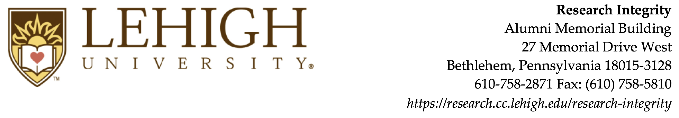

Baggage (BAG) Export License Exception Certification

Export License Exception BAG (Baggage) allows individuals leaving the U.S. temporarily to take personal items, including personal hardware, software, and retail-level encryption items, so long as the items are for personal use. Individuals leaving the U.S. temporarily must bring back the items exported under this license exception unless the items are consumed or destroyed abroad.
This BAG certification must be completed for each international trip and whenever any changes occur. The completed form is to be retained by the traveler while in transit. Contact the Office of Research Integrity if you are not sure if the BAG exception applies or if you have questions about its contents.
Traveler:

Destination:

Date(s) of Travel:

Technology Information

Item Type | Make / Model / Details | Description of item(s)
Laptop
Smartphone
Tablet
Software
Other

Certification

By my signature below, I certify that:
- I personally own the items, technology or software that I am taking abroad to the country(ies) noted above.
- I am not shipping the items as unaccompanied baggage.
- The items, technology or software noted above are intended for necessary and appropriate personal use only.
- The items, technology or software noted above are not intended for sale or other disposal.
- I will return all the items, technology and software noted above to the U.S.
- I will keep the items under my "effective control" while abroad (“Effective control” means items must stay in my physical possession in a locked and secured environment such as a hotel safe, a bonded warehouse, or a locked or guarded exhibition facility).
- I will take security precautions to protect against unauthorized releases of technology while the items are being shipped or transmitted and used during my travel, such as:
- Using secure / encrypted connections when accessing email or other business activities that involve the transmission and use of the technology
- Use of password systems on electronic devices that store technology
- Use of personal firewalls on all electronic devices that store the technology
- I will not access export controlled, restricted, confidential or sensitive information that may be stored on cloud / web-based storage servers during my travel.
- I will not take any item or software incorporating Lehigh University developed, non-commercial strong encryption source code outside United States territory unless I have received approval in advance from Lehigh’s Office of Research Integrity in writing.
- I will not ship or hand-carry any items, technology or software to embargoed countries (e.g., Cuba, Syria, Sudan, Iran, North Korea) without consulting Lehigh’s Office of Research Integrity in advance.

Traveler’s Signature: ______________________________

Date:

