Subcontractor Invoicing

ORSP is responsible for initiating the review, approval, and payment process for all subcontractor invoices. (These invoices are sent from other entities [mainly other institutions of higher education or industries] that performed work on sponsored projects in which Lehigh is the prime recipient of the award.)

It is the responsibility of the Accounts Coordinator to receive and review these invoices for completeness, comparing the invoice with Banner data, preparing the Accounts Payable Payment Approval form, obtaining proper approval from the Principal Investigator and Contract Grant Specialist, maintaining the Subcontractor Spreadsheet for tracking purposes, and communicating any discrepancies found to the Subcontractor and/or to the Contract Grant Specialist.

Reviewing Invoices/Updating Spreadsheet:

Subcontractor invoices are received on monthly, bi-monthly, or quarterly basis or as work is performed on the sponsored project. The invoices are emailed to the ININV account or mailed through US mail.

- Save the invoice to the I:drive using the following path:

I:\ORSP_RACCT\Subrecipient Documents\1 Sub AP Vouchers CJ RACCT\SUBCONTRACTOR INVOICES\2021 Invoices

Naming convention: 54xxxx-7800x [Invoice Period: Month & Year]

(If the invoice was received through US Mail, scan to email and save invoice as stated above.)

- Move email to “Invoice” label.

- Open Excel Spreadsheet: I:\ORSP_RACCT\Subrecipient Documents\1 Sub AP Vouchers CJ RACCT\SUBCONTRACTOR INVOICES\SUBCONTRACTOR LIST.xls
(Password 7583022)

- Find sheet with grant number of invoice and create a new row.

NOTE: If this is a new subcontractor, you will need to create a new sheet. Use the BLANK COPY (the very first sheet) to make a copy. Right click on the BLANK COPY sheet, select Move or Copy, under “Before Sheet” scroll through to find and select the appropriate place to add the sheet so it will be in numerical order, check the box at the bottom to “Create a copy”, and then click Ok. Right click the new sheet and select “Rename” and label the sheet the grant number found on the invoice.

- Populate the following fields on the spreadsheet: Index, Index Description, Sub-Code, PI, C2, CGS, Subcontractor, To PI, Amount, Invoice Period, Invoice Number, Invoice Date, & Date Received.

The below information can be found in Banner, everything else should be stated on the invoice.

Go to Banner Form: FRAGRNT
Type grant # and click Go.

- The Index Desc will be the same as the Title in FRAGRNT (Note: if you take your cursor and hover over the title field box, a box should appear that shows a shortened title but a few characters longer than what actually appears in the field box, this is what should be entered in the spreadsheet)
- To look up the PI, C2, & CGS, click on the Personnel Tab at the top and arrow down to Project Investigator for PI, Fund Administrator for C2, & Program Administrator for CGS.

Verify the project end date, subcontract budget, encumbrance, and subcontractor address and contact information as this information needs to be updated on the spreadsheet periodically.

- The project end date is on FRAGRNT towards the middle of the screen.
- To verify the subcontract budget, when in the FRAGRNT form, go to Related (top right-hand side), click on FRIGITD (make sure the only field populated is the grant number), click Go. Scroll down to the appropriate subcontractor line item (7800x) and verify the adjusted budget matches the spreadsheet.
- Also, review the available balance (column on the far right) and that there are sufficient funds available to pay invoice. Please note, if the subcontractor is encumbered, the available balance will show zero but there will be funds in the commitment column. See below. This is ok –there are sufficient funds.

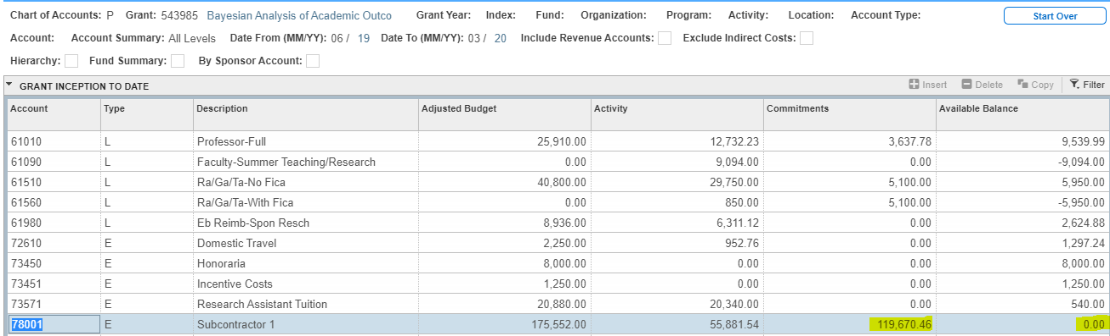

**IF YOU FIND THERE ARE NOT SUFFICIENT FUNDS AVAILABLE, STOP & NOTIFY THE CGS FOR FURTHER INSTRUCTIONS ON HOW TO PROCEED; DO NOT SEND DOCUSIGN ENVELOPE TO PI**

- To verify the encumbrance number, when in the FRIGITD form, highlight the appropriate subcontractor account code (7800x), go to Related, click on FRIGTRD,
press F7 to filter, on Add Another Field, select “Field”, type “ENC” in field box and press F8 to query. View the Document column for a PU0xxxxx number. This is the encumbrance/PO number that is entered on the spreadsheet and also the AP Form. **Not all subcontractors are encumbered**

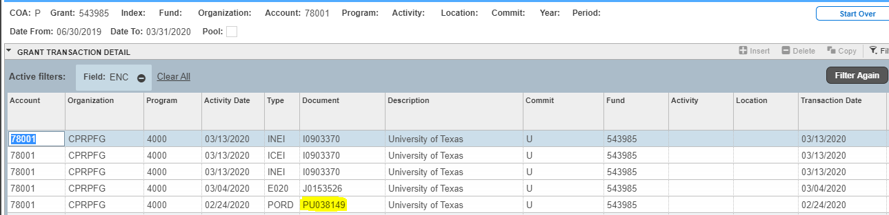

Any issues with encumbrances - contact Linda Roberts in Purchasing Office for assistance.

- The subcontractor address and contact information will be on the invoice and/or the email that was sent with the invoice. Verify that this information is up to date.
- Lastly, make sure that cumulative totals and outstanding balances on invoices agree with our spreadsheet. Any disagreements that are found on the invoice should be communicated to the Subcontractor using their contact information.

NOTE: If an outstanding balance exists, double check Banner to see when the last invoice was paid. If a month or more passed, contact the subcontractor to research and see if payment was received. We may be asked to show proof of payment, in which case, we will need to contact our Accounts Payable department for a copy of the cancelled check.

Once the spreadsheet is updated with the appropriate information from the invoice and everything looks accurate, the approval process can be initiated via DocuSign.

DocuSign Approval Process:

- Open DocuSign using your Lehigh email address.
- Click on Start and choose Send an Envelope on the drop down menu.

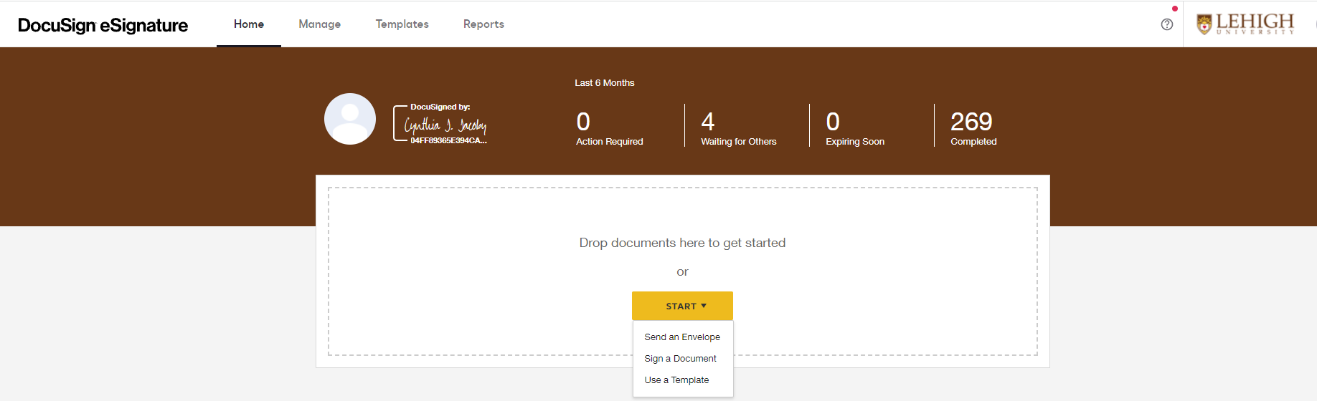

- Under Add Documents to the Envelope, select Upload, and locate the pdf file of the invoice that was saved on the I:drive and click Open.

- After the invoice is uploaded, select Use A Template. A window will populate and on the left-hand side under Shared Folders, select the ORSP folder and check the box next to ORSP Subrecipient Invoice Approval and click Add Selected at the bottom.

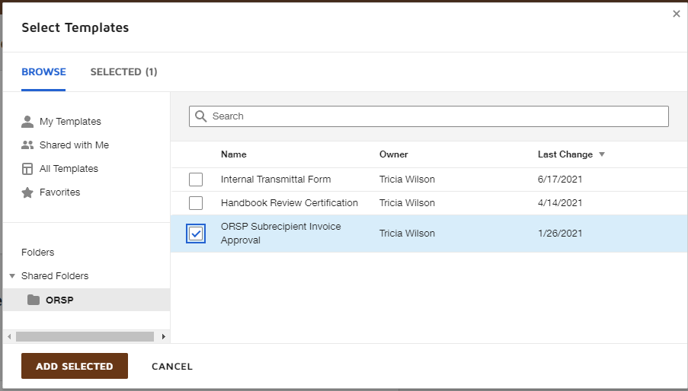

This will add 3 additional documents to the envelope in addition to the invoice: The Subrecipient Invoice Approval, Accounts Payable Payment Approval Form, and the Foreign Wire Transfer Form.

- Delete the last document: Foreign Wire Transfer Form. Hover mouse over document and there should be an “X” on the top right. Click the “X” and click Delete. (Note: this form is obsolete; there is a revised form located at the following path: I:\ORSP_RACCT\Subrecipient Documents\1 Sub AP Vouchers CJ RACCT named Outgoing Wire Transfer Request Form – Rev. Nov. 2020.docx that should be used if the subcontractor is a foreign entity.)
- Verify the documents are in order: Subrecipient Invoice, Subrecipient Invoice Approval Form, Accounts Payable Approval Form. If not click and drag, so they are in the proper order.
- Next, recipients need to be added to the envelope. Review spreadsheet for C2, PI, & CGS. Add the appropriate Department Coordinator (C2 from the spreadsheet), Principal Investigator, & Contract & Grants Specialist per the appropriate field boxes in DocuSign. Enter their name and Lehigh email address. (The Accounts Coordinator and Accounts Payable recipients should populate with the corresponding individuals along with their email address.)

NOTE: If there is no coordinator listed on the spreadsheet, delete the Department Coordinator recipient. This can be done by hovering over the right-hand side of the coordinator field box - an “X” should appear to the right of the box. Click the “X”. You will also need to go down to signing recipient number 4 as the department coordinator receives a final copy of the envelope during this phase of the approval process too.
- After recipients are added, scroll down to Message to All Recipients section. Note, each recipient has a customized message per their individual role. The email subject line is the only text that needs to be edited. Remove bracketed information and replace with the subcontractor’s name (for the institution), amount of the invoice, & the PI of the grant.

(For example, ORSP Subrecipient Invoice Approval Florida Atlantic University - $7,772.49 – Herrera)

- Once this information is entered, copy and paste this subject line for each recipient as this remains the same for all.
- Select Next at the bottom right-hand side
- Finally, scroll through and review documents that were attached.

- Verify that the appropriate invoice was uploaded to envelope.
- Top section of the subrecipient invoice approval form needs to be completed. Populate field boxes for Fund Number, Invoice Number, Subrecipient Institution, Subrecipient PI, Invoice Date, and Invoice Time Period. All information should be retrieved from the invoice and/or the subcontractor spreadsheet.

The bottom portion of the form should be left blank for the PI to complete.

See sample below.

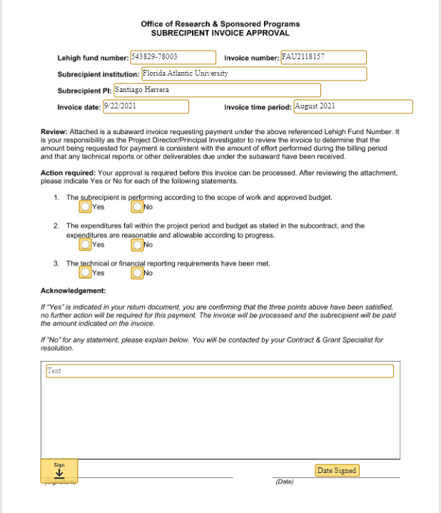

- Complete the Accounts Payable Payment Approval form. The items that need to be entered are the date sent, payee name & address, index number, account code, dollar amount, and business purpose. If the subcontractor is encumbered, make sure the PO# is listed in the “Other” section.

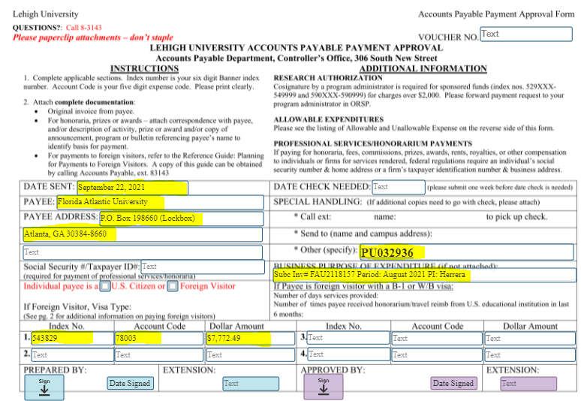

- Select Send at bottom right-hand side.

This will send the envelope to the coordinator (if one is listed) and the PI for approval.

** A response is needed from the PI in order to continue. **

- Once you receive an email notification that an invoice has been reviewed by the PI and a response is enclosed, via the ININV email account, move email to the “Processed Invoices” label.
- Open DocuSign

Note: This time you will need to login to DocuSign via the ininv account. In order to do this, you will need to login to DocuSign via a browser other than chrome and use the ininv@lehigh.edu email address. You will be prompted to enter the Lehigh Username and Password – use ininv as your username & invoices32 as the password.

- On the Home page, click Action Required at the top.

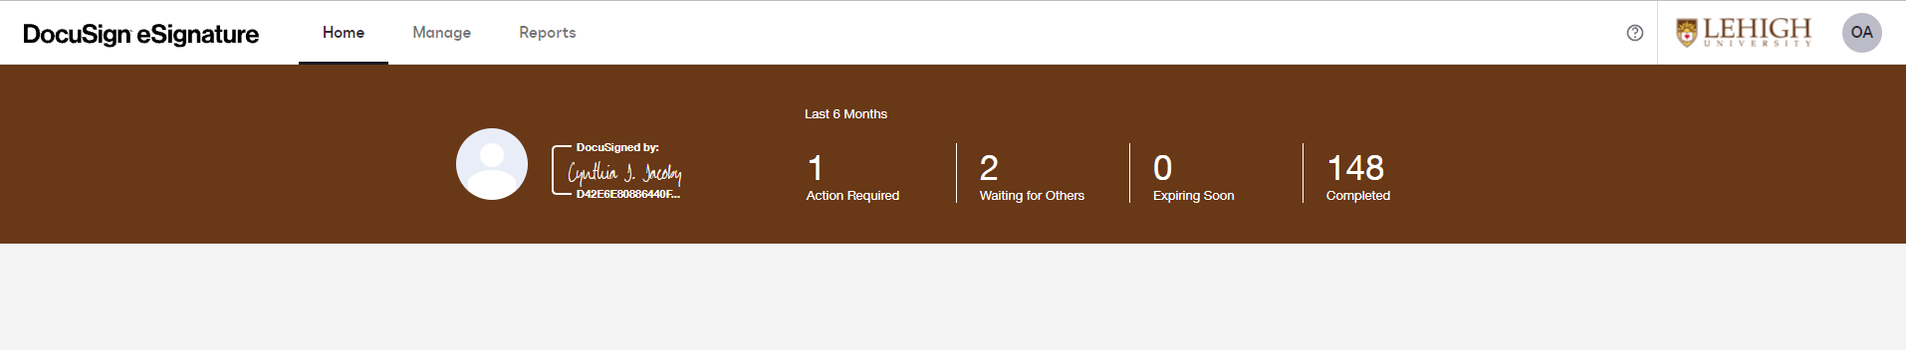

This will open your queue of invoices that needs the Accounts Payable form signed.

- Click Sign on the right-hand side of the invoice.

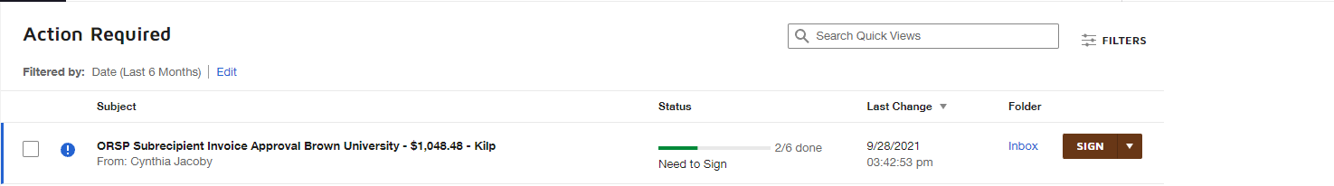

- Click continue to review documents and sign.

- Review the Subrecipient Invoice Approval page and verify that PI answered “Yes” to the 3 statements and signed the bottom of the form.

** IF THEY ANSWERED “NO” ON ANY OF THE STATEMENTS, STOP & NOTIFY THE CGS FOR FURTHER INSTRUCTIONS. **

- Review the Accounts Payable Payment Approval form and change the Date Sent to today.
- Verify all other information entered on the A/P form. If everything looks good click Sign under the Prepared By line and enter phone extension.

- Click Finish at top of screen. This will forward the envelope to the CGS for approval.
- Update Excel spreadsheet with date sent “To CGS”

** A response is needed from the CGS in order to continue. **

- Once you receive email that CGS opened and viewed document, go into DocuSign and verify that it was signed. If the CGS signed the form, update spreadsheet with date sent “To AP”

- Wait for the email that Michele Bennyhoff in A/P opened and viewed your document and the subsequent Completed email. Once you receive these emails the process has been completed.

NOTE: This does not mean that A/P processed payment only that they received the DocuSign Envelope. It usually takes a few days before payment is processed and a check is cut for distribution. This is verified in Banner at a later date.

